Editorial Board

Mr. B. Mohan Kumar
Mr. G.N. Satish Kumar
Dr. D. Shireesha
Mrs. P. Arpitha
Mrs. T.V. Ratnavali
Ms. Ch. Vasantha
Mr. R. Bhadra Rao

BULLETIN

NSS Activity
- Haritha Haram
- Cancer Awareness Talk

Faculty Achievements
- HOD-MBA as expert speaker at National Workshop
- FDP and National Seminars
- National Summit on Microfinance
- Workshop on EBSCO

Activities on and off the campus
- Iftar Party
Realty Bytes

Director’s Message
Editorial

Dear All
Welcome to the July’s edition of Aurora Gazette. The campus had been buzzing with activities as well as serious studies as the students of MBA II semester gave their II internal exams in the beginning of the month and end semester exams from the 3rd week of July. On completion of internal exams, students organized Iftar Party and invited the members of the college. NSS activity for the month was a Cancer Awareness Talk by Dr. Chinna Babu Sunkavalli; our faculty members attended various workshops, seminars and national summits. The college responded to the green revolution movement- Haritha Haram that was initiated by the Telangana Government.

Thank you. We hope you will find Aurora Gazette informative.
Please send your articles and other contributions to newsletter.apgm@gmail.com

NSS ACTIVITIES

Haritha Haram

Students of the college played an active role in the Haritha Haaram drive organized by the residents of Saleemnagar, Moosarambagh on Sunday 10th July 2016.

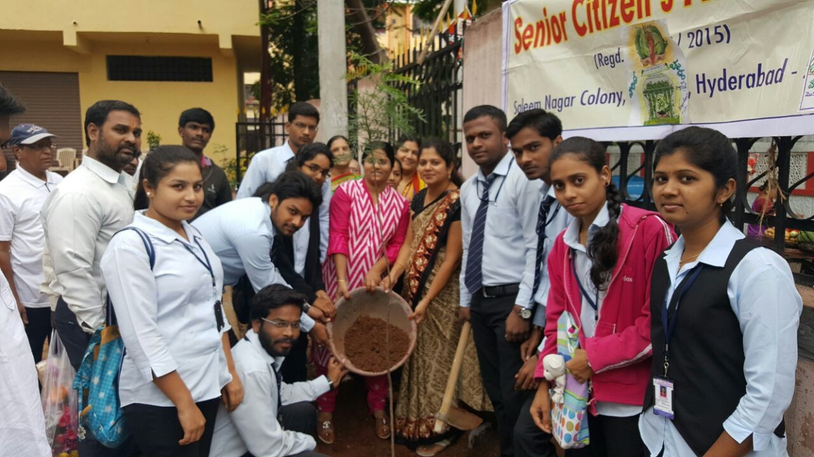
On 11th July, the college organized an NSS activity that involved adding some more saplings and plants in the campus that is already dotted by plants and trees of various types. The activity is an answer to the initiative taken by the Hon’ble Chief Minister of Telangana to spread greenery in the state. The Director, HODs of MBA and MCA, faculty members and students participated in the program. The Staff of the college spoke about the greenhouse effect, depletion of natural resources and the situation in the future and felt that it is essential to safeguard greenery.

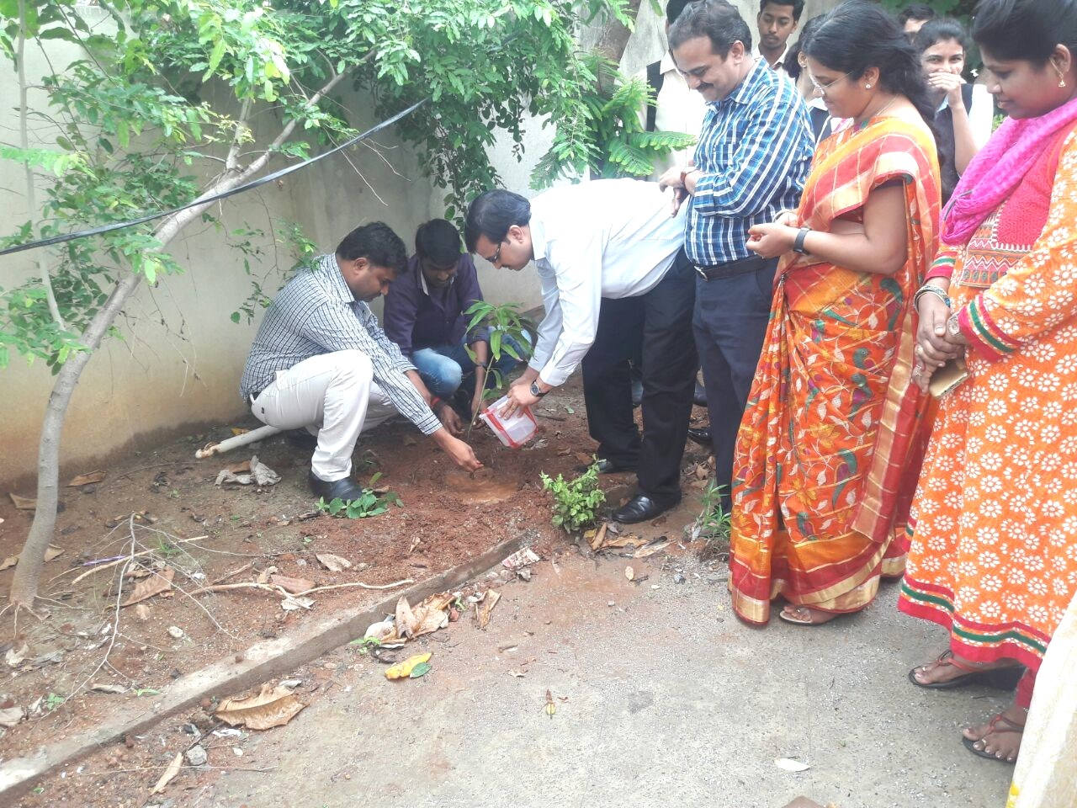

Cancer Awareness Talk
The Aurora’s PG Colleges have invited Dr. S. Chinna Babu Sunkavalli, Specialist in Oncology for a talk on cancer awareness on 12th July. Sri N. Raja Babu, Chairman-Aurora Consortium arrived as the Chief Guest for the event. Dr. Chinna Babu who is also specialized in Robotics and its application into cancer treatment spoke of the conditions and life styles that lead to cancer. He also recommended preventive measures that are required by men and women after crossing certain age and said that these tests are mandatory if one wants to avoid such serious malady.

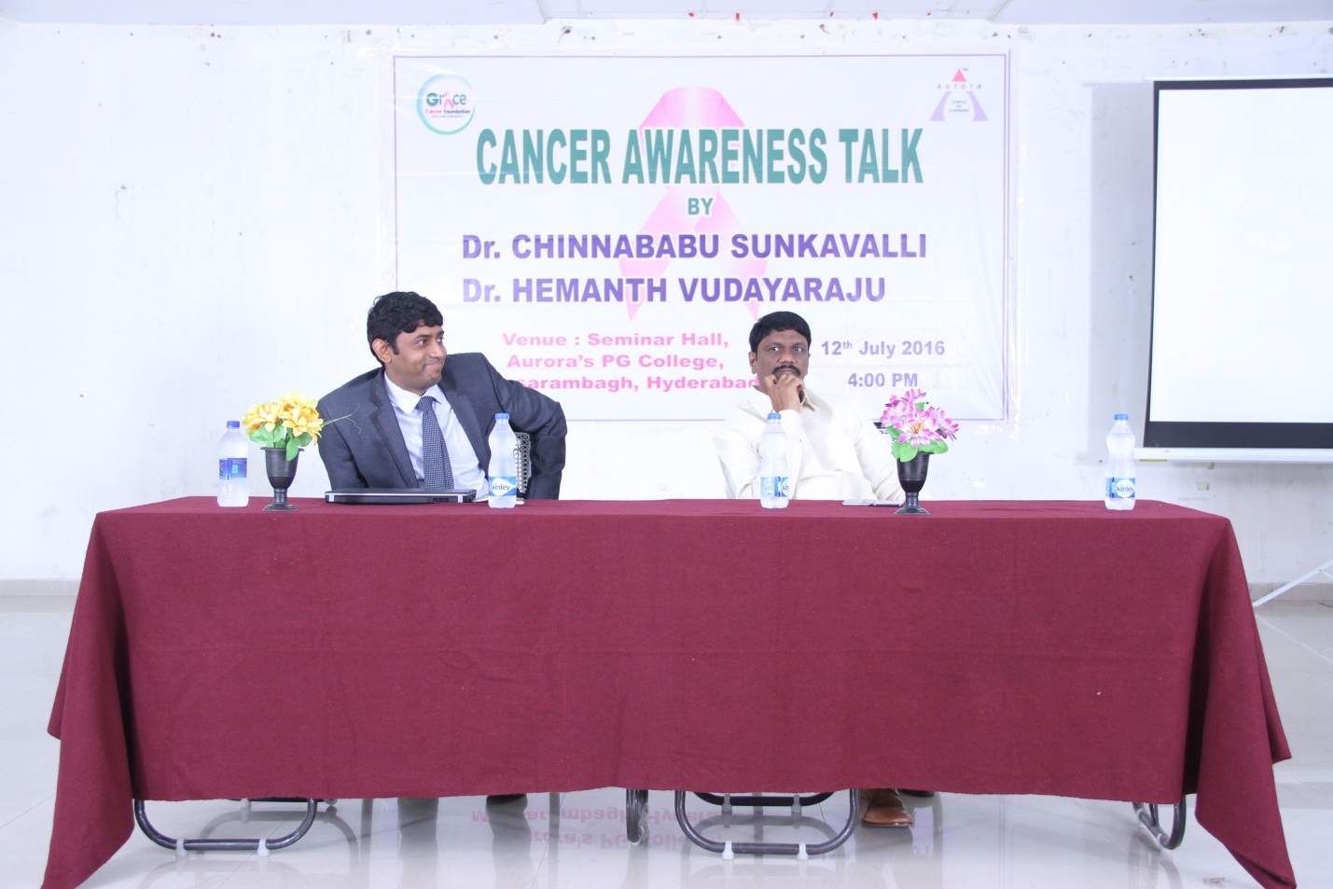

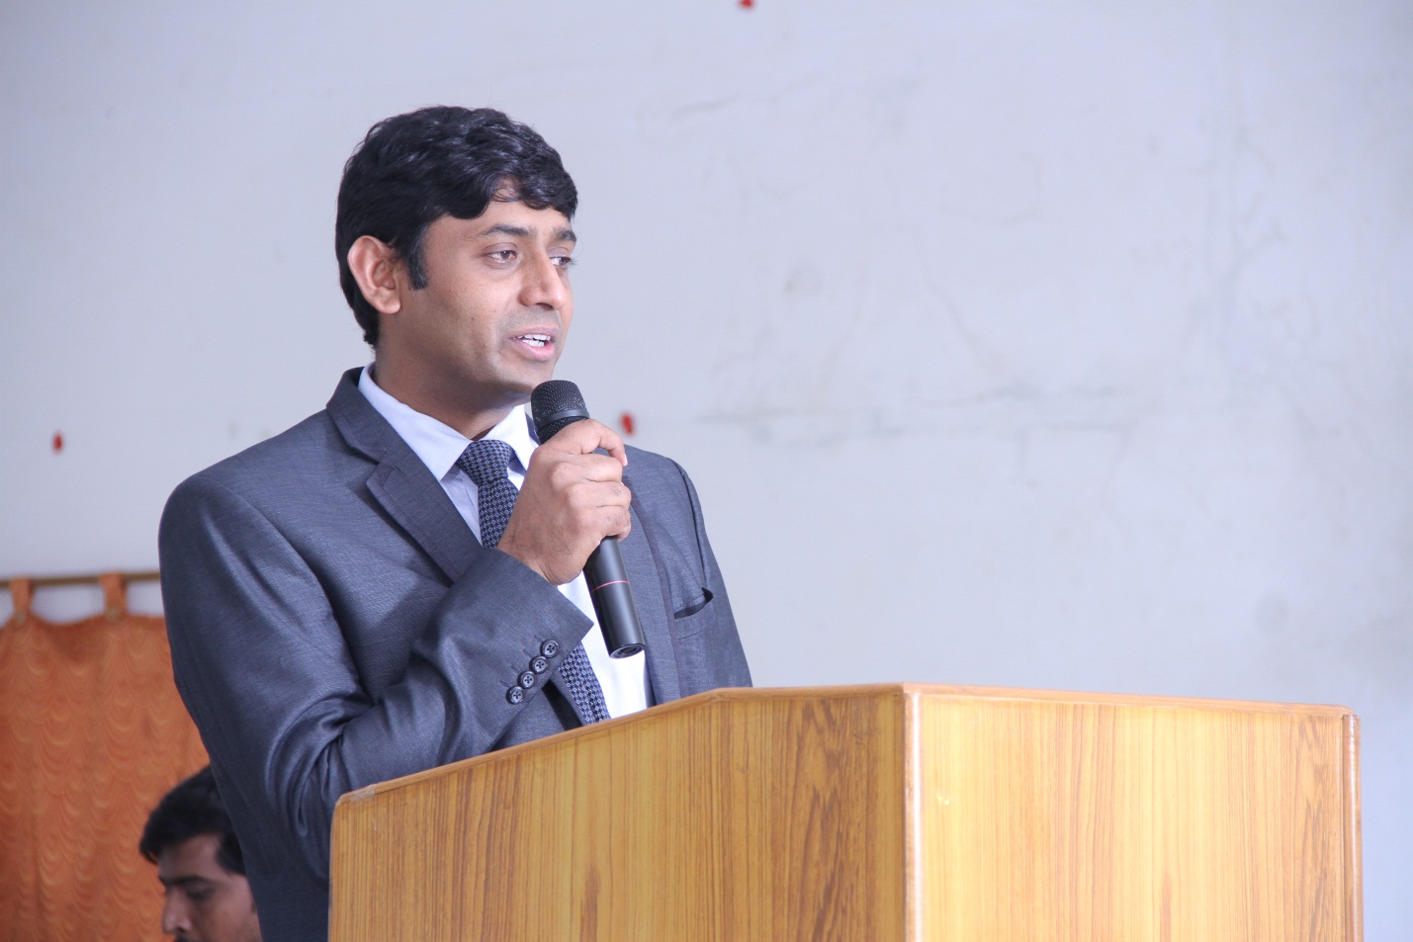

FACULTY ACHIEVEMENTS

HOD-MBA as expert speaker at National Workshop
The HOD-MBA, Mr. G.N. Satish Kumar was invited as Expert Speaker by Acharya Nagarjuna University, Guntur for the National Workshop on Research Methodology and Data Analysis-SPSS that was organized on 4th and 5th of July 2016. The college congratulates Mr. Satish Kumar for this achievement and wishes that he represents the college in many such events.

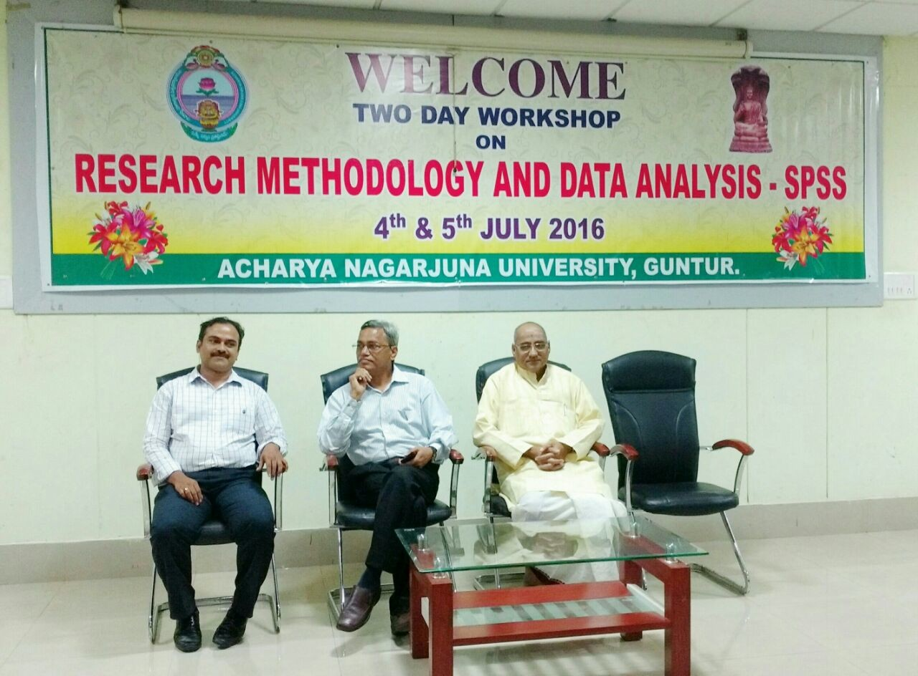

FDP and National Seminars
A week long seminar was organized from 27th July to 2nd August 2016 at St. Francis Degree and PG College for Women, the theme being Emerging Trends in Research Methodology. Two faculty members attended the workshop and not only made presentations but also got their empirircal research papers published in the Seminar Proceedings with ISBN number.

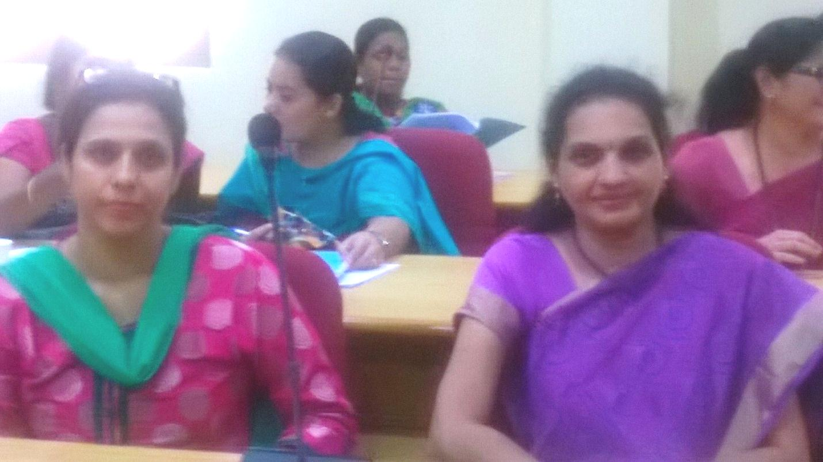

National Summit on Microfinance
ASSOCHAM has organized National Summit on Microfinance in association with Microfinance Institutions Network (MFIN) on 19th July 2016 at Hotel Taj Krishna, Hyderabad to strengthen the confidence in financing small business entities and to chalk out a feasible and effective agenda for the overall development of this sector.

Microfinance Institutions Network (MFIN) was based on the theme of the summit and various case studies, success story of emerging enterprises and global practices. This report was released at the summit by Hon’ble Governor.

The focus areas of discussions were role of MFIs in financial inclusion; ensuring financial discipline in administering micro finance products; and taking microfinance to un-served/ under-served areas. The deliberations in the Inaugural/Technical sessions would serve as a game-changer and help authorities in addressing the issues which may be raised by different stakeholders. The representatives who attended the Summit were Mr. Raghavendra and Mrs. Prasanna Lakshmi.
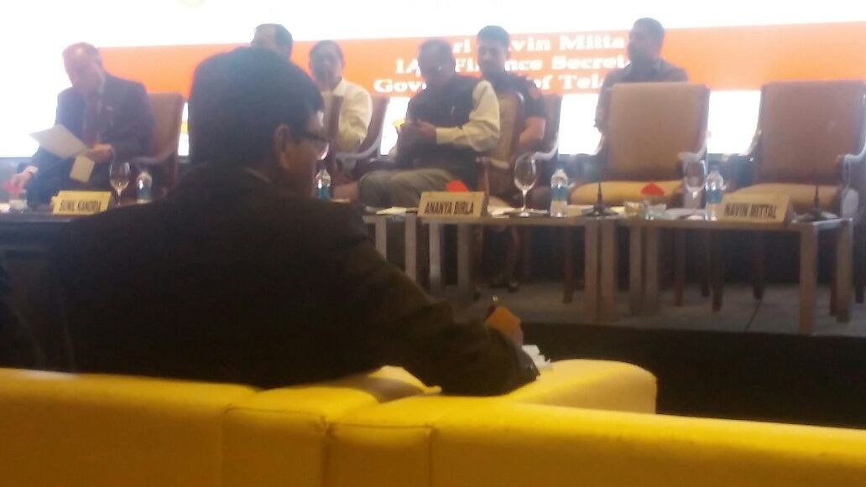

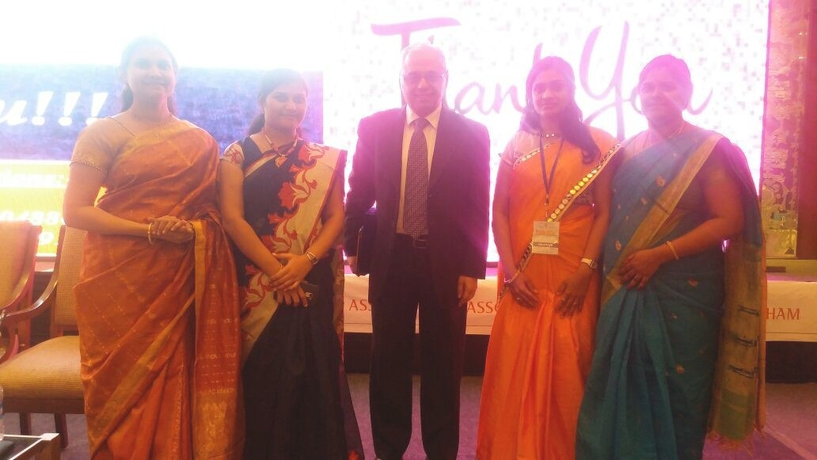

Workshop on EBSCO
Faculty members of the college were invited to be a part of a workshop on EBSCO at Aurora’s PG College, Ramanthapur on 27th July 2016. The contents of workshop highlighted the advantage of EBSCO installed in libraries; benefits of research and incubation centers etc.
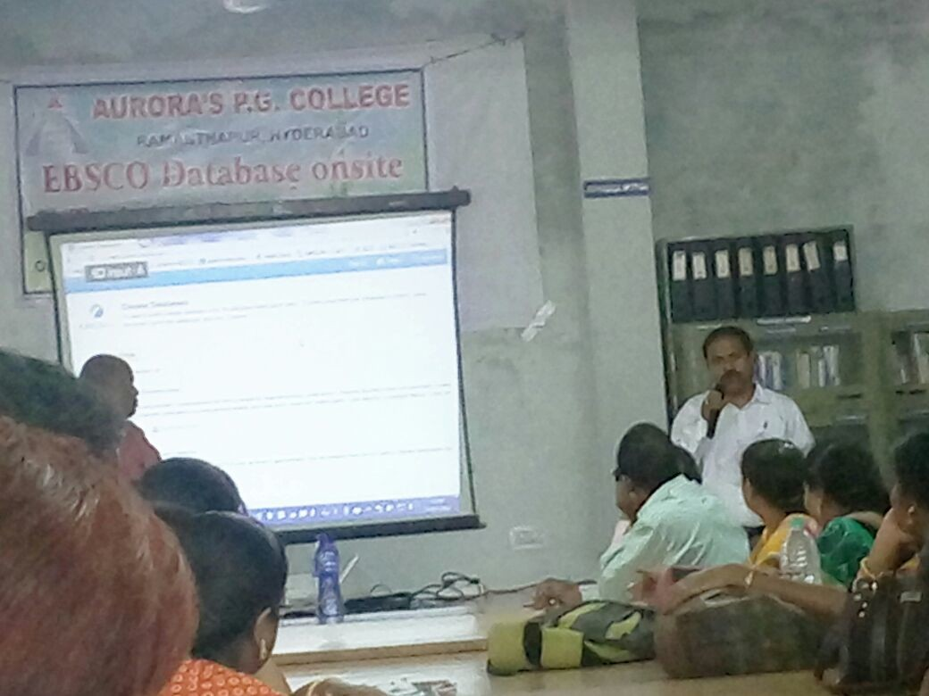

Activities on and off the campus
- Iftar Party
Ramadan is an Islamic month of fasting. In this month, Muslims fast for 30 days, refraining from eating from sunrise (fajr) to sunset (maghrib). Each morning one eats before sunrise at the time of ‘Seher’, this is followed by a day of fasting, ending with a meal at sunset called ‘Iftar’.
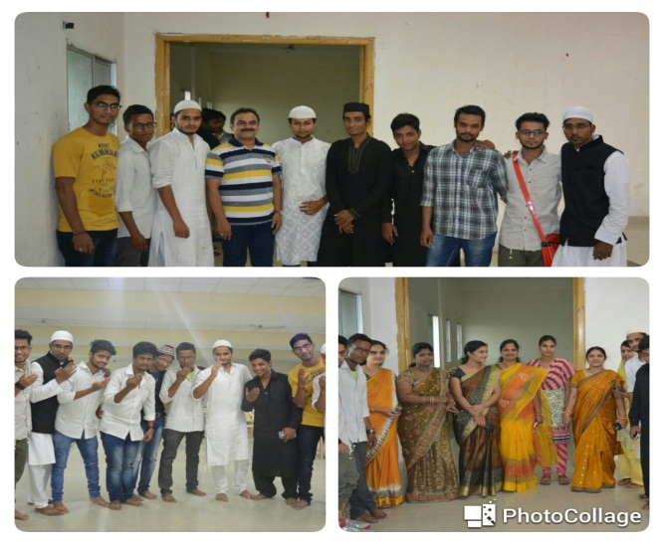

Iftar is the meal eaten to break one’s fast during the holy month of Ramadan. During this month, also the ninth month of the Muslim calendar, Muslims believe the first verses of the Qur’an (Sacred book of Islam) were revealed to Prophet Muhammad - Peace Be Upon Him (PBUH). In essence, from sunrise until sundown, Muslims around the world focus on practicing abstinence in its entirety, particularly by refraining from eating and drinking from sunset through sundown. The act of fasting during Ramadan is one of the five pillars of Islam. Ramadan in 2016 is on June 6th (or with the sighting of the new moon) and last through July 6th (or until the next sighting of the new moon). During the hours of fast, Muslims are encouraged to read the Quran, refrain from smoking, sex, ill-thinking and ill-doing.
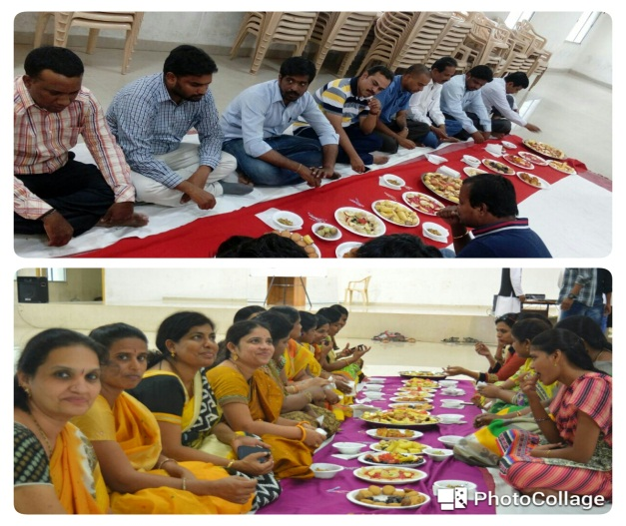
In the month of Ramadan, Iftar parties are often hosted in families and friends to share the reward and blessings of sharing food and prayers together as one community and family.
The Students of Aurora PG College Moosarambagh organized Iftar party on 2-07-2016 to celebrate Ramadan. All the staff members participated in this auspicious occasion.

Realty Bytes

Cancer Awareness Talk
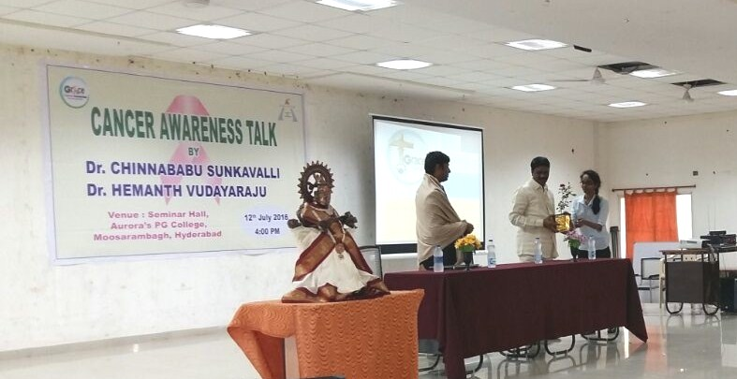

Mr. G.N. Satish Kumar as one of the delegates to the Workshop
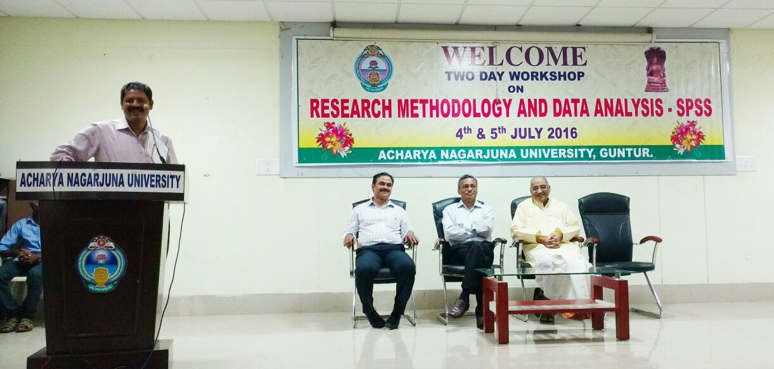
Haritha Haram at Saleemnagar, Moosarambagh
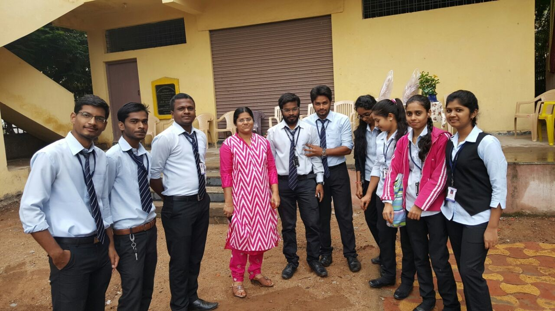

Haritha Haram
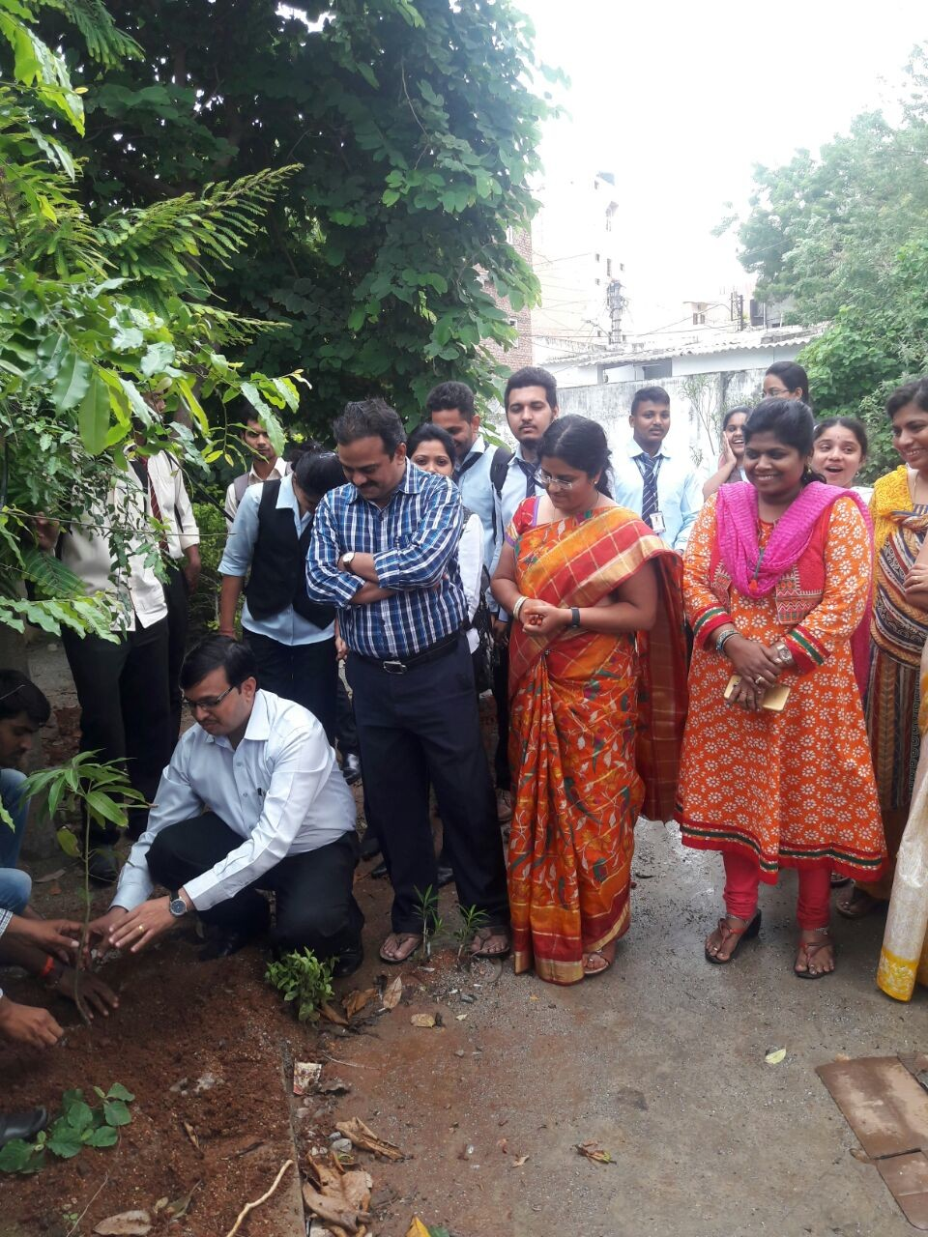
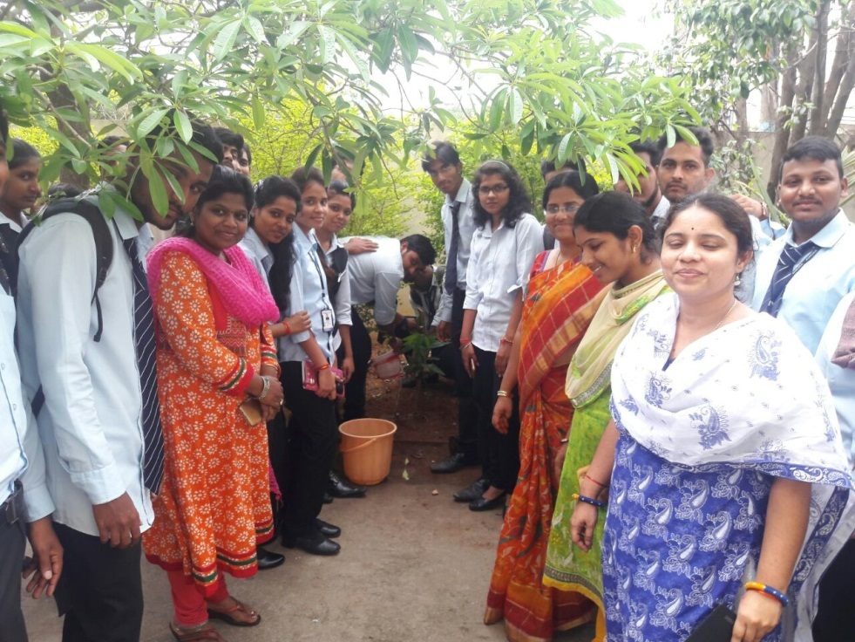
Faculty members at workshop at St. Francis Degree and PG College
