AURORA GAZETTE
Editorial Board

Mr. B. Mohan Kumar
Mr. G.N. Satish Kumar
Dr. D. Shireesha
Mrs. Arpitha
Mrs. T.V. Ratnavali
Mr. R. BhadraRao

BULLETIN
Director’s Message
Editorial
Faculty Achievements
Seminars &Guest lectures
- Seminar on Anti Corruption and RTI by YAC
Students Achievements
- Management Meet, PragathiMahaVidyalaya
- IT Meet, Aurora’s PG College, Ramanthapur
Placement & Internship activities
Activities in the campus
- Alumni Meet
- IT Quiz
- VikrayaVedika
- Business Quiz
- Cricket Tournament
Important Dates in March
Realty Bytes

DIRECTOR’S MESSAGE

EDITORIAL
The editorial board of Aurora Gazette is happy to be back again. The month of March went on with an air of professionalism-the second semester students of MBA organized a marketing activity following the foot steps of their seniors who successfully conducted Aaharotsav last month; they participated in Business Quiz and IT Quiz in large number. The students of MBA and MCA had to their credit participation in a Management Meet and an IT Meet. Cricket tournaments were conducted. Large number of students successfully cracked interviews and got internships in top notch organizations like Wipro, Bajaj Finserv. Our college had become the platform for a seminar organized by an association called YAC (Youth Against Corruption)

Thank you. We hope you will find Aurora Gazette informative
Please send your articles and other contributions to newsletter.apgm@gmail.com

FACULTY INTERACTION WITH THE OUTSIDE WORLD
Mr. G.N. Satish Kumar, HOD-MBA visited RBVRR College, Koti for Women and St. Joseph’s Degree and PG College, King Koti as external evaluator of Viva Voce Examination

SEMINARS &GUEST LECTURES
Seminar on Anti-Corruption & RTI by Youth AgainstCorruption
An NGO organization called YAC (Youth Against Corruption) has given a seminar and educated students on the different forms of corruption and the Right To Information Act which many of us ignore or are not aware. The Convenor of Youth Against Corruption Mr. RajenderPalnati began the session by stating the reasons behind the inception of YAC, its approach and active members of the association. Legal Advisor-RTI, Mr. SrinivasMadhav stated that the revolution that started ten years ago is giving fruits of RTI to common public. The Chief Guest, of the program- Commissioner, RTI, Dr. VenkateswarluGaru spoke about the RTI and its uses. The Director of the college, Mr. B. Mohan Kumar told the gathering that Aurora Consortium always encouraged such initiatives that are meant for the betterment of the society. The dignitaries later urged all the students to use RTI as weapon against corruption and informed them that help is available anytime with their organization in times of need.

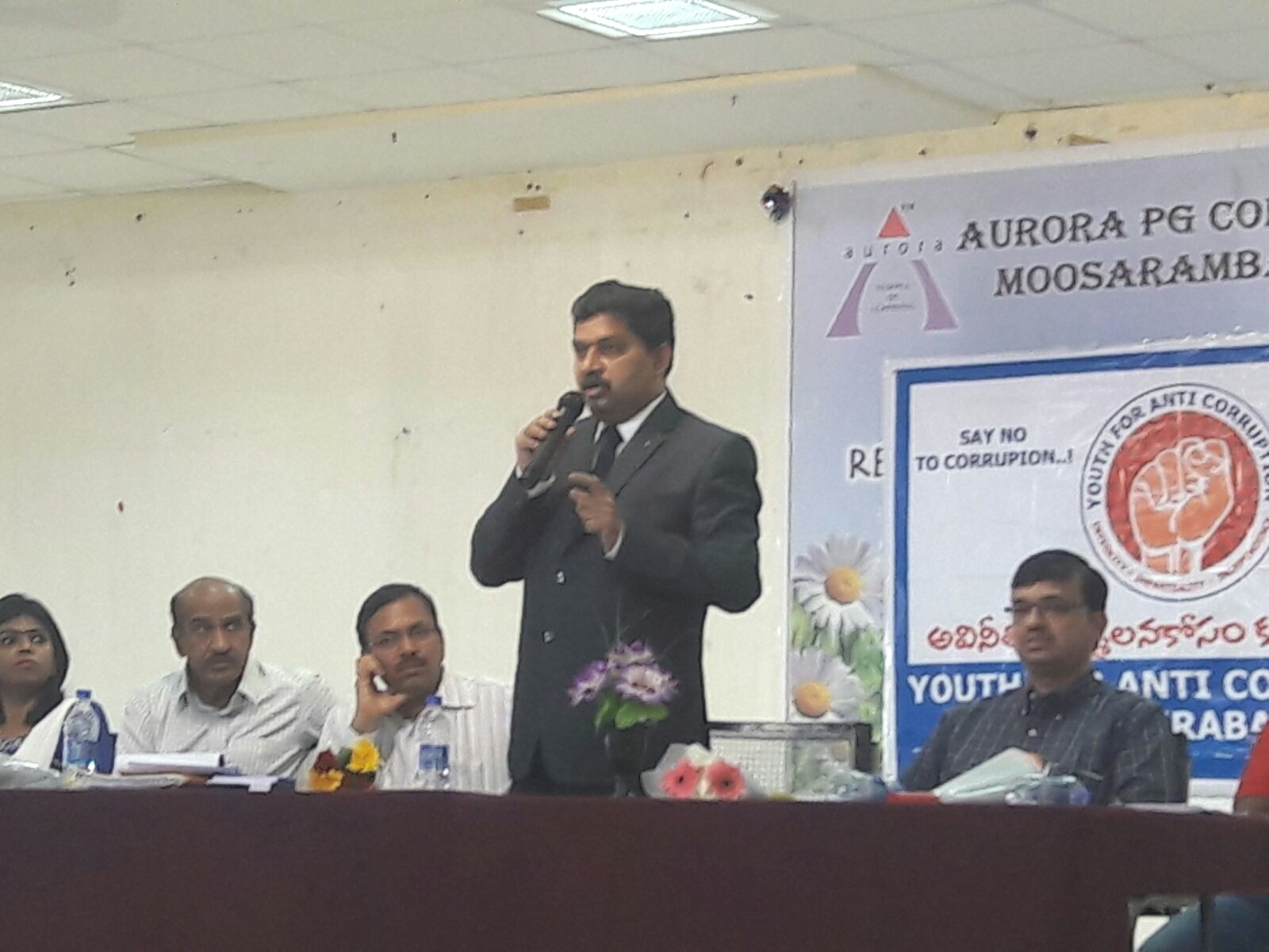

STUDENTS’ ACHIEVEMENTS
Sankalp 2k16- Management Meet atPragatiMahaVidyalaya Degree and PG College
On 16th March 2016, twenty students of the college attended Sankalp 2k16, Management Meet organized by Department of Management, PragathiMahaVidyalayaDegree and PG College and participated in formal competitions like Young Manager, Ad making, Collage, Business Quiz, Paper Presentation, Treasure Hunt. In informal events the students excelled in singing, dance competitions etc.

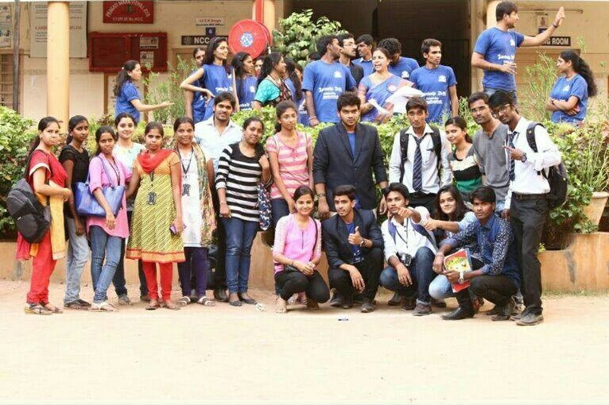

Annual IT Meet, Aurora’s PG College, Ramanthapur
On 19th March 2016, the MCA students of the college participated in Abhyasa, the IT Meet at Aurora’s PG College, Ramanthapur and won the following prizes:
SaiVara Prasad G & M Pavan Kumar won first prize in a competition called IT Quiz Buster; the winning team of Silver Screen comprised of Prathyusha&SaiVaraprasad G. prize; and in Proscenium, SaiVaraPrasad G bagged the second prize.

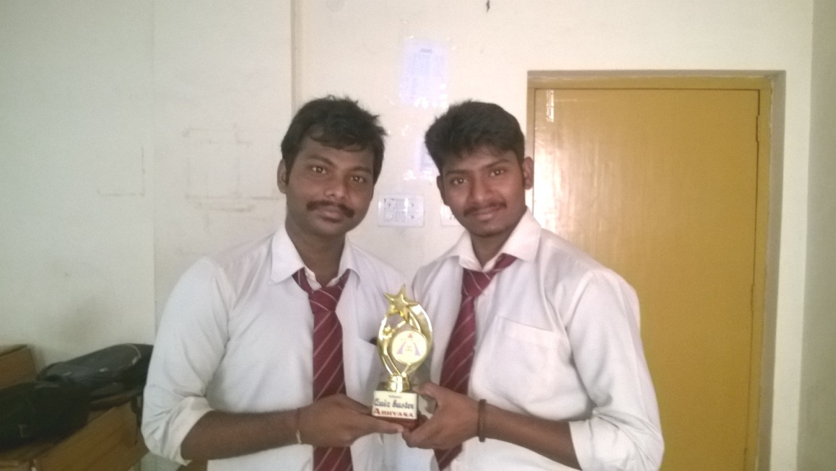

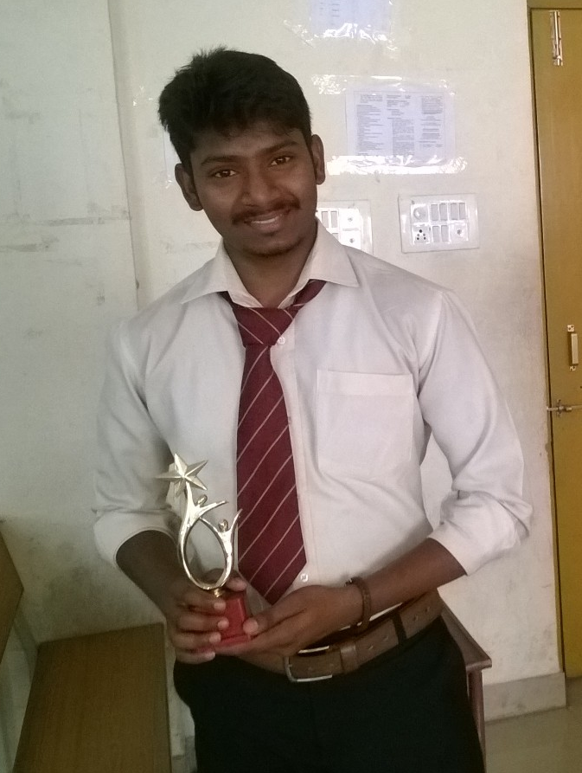

INTERNSHIP ACTIVITIES

Internship for students of MBA II semester
S.No. | Name of the Student | Company
1 | G. Abhilash | Birla Sun Life Insurance Company Limited (BSLI)
2 | N. Pavan Kumar | Birla Sun Life Insurance Company Limited (BSLI)
3 | P. ShashiKanth | Birla Sun Life Insurance Company Limited (BSLI)
4 | G. Shiva Ram | Birla Sun Life Insurance Company Limited (BSLI)
5 | E. Nagaraju | Birla Sun Life Insurance Company Limited (BSLI)
6 | C. Sai Kumar | Birla Sun Life Insurance Company Limited (BSLI)
7 | K. Vinay Kumar | Birla Sun Life Insurance Company Limited (BSLI)
8 | V.S. Abhilash | Birla Sun Life Insurance Company Limited (BSLI)
9 | A. Pavan Kumar | Birla Sun Life Insurance Company Limited (BSLI)
10 | C. Mani Prasanth | Birla Sun Life Insurance Company Limited (BSLI)
11 | SaiJayesh | Birla Sun Life Insurance Company Limited (BSLI)
12 | B. Achyut Reddy | Birla Sun Life Insurance Company Limited (BSLI)
13 | PiyushAgarwal | Birla Sun Life Insurance Company Limited (BSLI)
14 | T. Vijay Kumar | Birla Sun Life Insurance Company Limited (BSLI)
15 | M. Vinod Kumar | Birla Sun Life Insurance Company Limited (BSLI)
16 | CH. Ashok | Birla Sun Life Insurance Company Limited (BSLI)
17 | K. Kranthi Kumar | Birla Sun Life Insurance Company Limited (BSLI)
18 | ShaikMohdRehanSharjeel | Birla Sun Life Insurance Company Limited (BSLI)
19 | S. Praneeth Kumar | Birla Sun Life Insurance Company Limited (BSLI)
20 | SaiPrabhuKshirsagar | Birla Sun Life Insurance Company Limited (BSLI)
21 | R. Amarnath | Birla Sun Life Insurance Company Limited (BSLI)
22 | Amar Bin Mohsin | Birla Sun Life Insurance Company Limited (BSLI)
23 | HarshitaAgarwal | Birla Sun Life Insurance Company Limited (BSLI)
24 | G. Srinivas | Birla Sun Life Insurance Company Limited (BSLI)
25 | BathulaSai | Birla Sun Life Insurance Company Limited (BSLI)
26 | ShankpalShashikanth | Birla Sun Life Insurance Company Limited (BSLI)
27 | AamerSohail | Birla Sun Life Insurance Company Limited (BSLI)
28 | B. Raghunath Reddy | Birla Sun Life Insurance Company Limited (BSLI)
29 | M. Soundarya | Birla Sun Life Insurance Company Limited (BSLI)
30 | Anjali Mishra | Birla Sun Life Insurance Company Limited (BSLI)
31 | G. PrathyushaSravan | Birla Sun Life Insurance Company Limited (BSLI)
32 | SaiSwethaRajavarapu | Birla Sun Life Insurance Company Limited (BSLI)
33 | SirishaBolli | Birla Sun Life Insurance Company Limited (BSLI)
34 | Shirini G | Birla Sun Life Insurance Company Limited (BSLI)
35 | M. Laharika | Birla Sun Life Insurance Company Limited (BSLI)
36 | MD. Khalel Ulla | Birla Sun Life Insurance Company Limited (BSLI)
37 | KosireddyDurga | Birla Sun Life Insurance Company Limited (BSLI)
38 | Monika Nelwade | Birla Sun Life Insurance Company Limited (BSLI)
39 | T. Komal | Birla Sun Life Insurance Company Limited (BSLI)
40 | Sudeshna K C | Birla Sun Life Insurance Company Limited (BSLI)
41 | G Mounika | Birla Sun Life Insurance Company Limited (BSLI)
42 | KolapurDayal Monica | Birla Sun Life Insurance Company Limited (BSLI)
43 | B Bhargavi | Birla Sun Life Insurance Company Limited (BSLI)
44 | K Sulochana | Birla Sun Life Insurance Company Limited (BSLI)
45 | ShaikAther | Birla Sun Life Insurance Company Limited (BSLI)
46 | N. Pranay Kumar | Birla Sun Life Insurance Company Limited (BSLI)
47 | KapraveniShirisha | Birla Sun Life Insurance Company Limited (BSLI)
48 | Mohammed Bin Omer | Birla Sun Life Insurance Company Limited (BSLI)
49 | Syed JeelaniBasha | Birla Sun Life Insurance Company Limited (BSLI)
50 | Zaid Ibrahim Md | Birla Sun Life Insurance Company Limited (BSLI)
51 | R Gurunath Reddy | Birla Sun Life Insurance Company Limited (BSLI)
52 | G Nikhila | Birla Sun Life Insurance Company Limited (BSLI)
53 | B Ravi Kiran | Birla Sun Life Insurance Company Limited (BSLI)
54 | K Mounika | Birla Sun Life Insurance Company Limited (BSLI)
55 | KasturiMounika | Birla Sun Life Insurance Company Limited (BSLI)
56 | AnjushreeMantri | Birla Sun Life Insurance Company Limited (BSLI)
57 | Mohd Imran Khan | Birla Sun Life Insurance Company Limited (BSLI)
58 | Naveen Kumar Veeramalla | Birla Sun Life Insurance Company Limited (BSLI)
59 | Shiva Kumar Gottipamula | Birla Sun Life Insurance Company Limited (BSLI)
60 | DeepikaKachhawa | Birla Sun Life Insurance Company Limited (BSLI)
61 | R Renuka | Birla Sun Life Insurance Company Limited (BSLI)
62 | T Shilekhya | Birla Sun Life Insurance Company Limited (BSLI)
63 | ReshmaKadam | Birla Sun Life Insurance Company Limited (BSLI)
64 | B Kiranmai | Birla Sun Life Insurance Company Limited (BSLI)
65 | Madhiri Naveen | Birla Sun Life Insurance Company Limited (BSLI)
66 | G Sandeep | Birla Sun Life Insurance Company Limited (BSLI)
67 | AdarshMaloo | Birla Sun Life Insurance Company Limited (BSLI)
68 | G. Vikas | Bajaj FinServ
69 | Mickey Naik | Bajaj FinServ
70 | L. Amareshwari | Bajaj FinServ
71 | G. Harini | Bajaj FinServ
72 | Nalla Ramakrishna Reddy | Bajaj FinServ
73 | E. Ravi | Bajaj FinServ
74 | R. Sai Kumar | Bajaj FinServ
75 | BeldeMadhu | Bajaj FinServ
76 | Chandolu Mani Prasanth | Bajaj FinServ
77 | PundalikRathod | Bajaj FinServ
78 | P. Bhasker Reddy | Bajaj FinServ
79 | Krishna TejaBandreddy | Bajaj FinServ
80 | D. Shivakumar | Bajaj FinServ
81 | Yedugani Monika | Bajaj FinServ
82 | K. Divya | Bajaj FinServ
83 | CH. Ashok | Bajaj FinServ
84 | PulluriSai Krishna | Bajaj FinServ
85 | Sana. Sai Krishna | Bajaj FinServ
86 | JajalaMahathi | Bajaj FinServ
87 | MounikaKasturi | Bajaj FinServ
88 | P. Yogitha Sharma | Bajaj FinServ
89 | C. Sai Ram | Bajaj FinServ
90 | Vemula Vijay Kumar | Bajaj FinServ
91 | MD. Shakeer | Bajaj FinServ
92 | DakojuPrabhuVara Prasad | Bajaj FinServ
93 | S. Sandeep | Bajaj FinServ
94 | Vale Suresh Kumar | Bajaj FinServ
95 | Syed Sajida | Bajaj FinServ
96 | D. BalaBhavani Ganesh | Bajaj FinServ
97 | N. SaiKarthikGoud | Bajaj FinServ
98 | M. Sandeep | Bajaj FinServ
99 | NenavathSrinivas | Bajaj FinServ
100 | G. Saritha | Bajaj FinServ
101 | B. Tejaswini | Bajaj FinServ
102 | T. Prashanthi | Bajaj FinServ
103 | V. Samatha | Bajaj FinServ
104 | P. Saikiran | Bajaj FinServ
105 | HimaniKezalSugandhi | Bajaj FinServ
106 | B. Vishnu | Bajaj FinServ
107 | K. Gopi Krishna | Bajaj FinServ
108 | S. Rajath Kumar | Bajaj FinServ
109 | G. Sharanya | Bajaj FinServ
110 | M. Keerthireddy | Bajaj FinServ
111 | JanagamaBharath | Bajaj FinServ
112 | Ambati Praveen | Bajaj FinServ
113 | NareshKaniganti | Bajaj FinServ
114 | Mohammad Shafiuddin | Bajaj FinServ
115 | S. Vijay Kumar | Bajaj FinServ
116 | Thakur Gaurav Raj Singh | Bajaj FinServ
117 | MadirajuGyanaNikhilesh Kumar | Bajaj FinServ
118 | Harshad Bharat Chauhan | Bajaj FinServ
119 | MP. Govind Reddy | Bajaj FinServ
120 | P. Nikhil Goud | Bajaj FinServ
121 | U. Abhishek | Bajaj FinServ
122 | Apuri Ram | Bajaj FinServ
123 | B. Raghunath Reddy | Bajaj FinServ
124 | P. Sandeep Kumar | Bajaj FinServ
125 | K. HimaBindhu | Bajaj FinServ
126 | P. Sirisha | Bajaj FinServ
127 | W. Amitkumar | Bajaj FinServ
128 | K. Harshavardhan Reddy | Bajaj FinServ
129 | K. Mahitha | Bajaj FinServ
130 | M. Ravali | Bajaj FinServ
131 | P. PriyaDarshini | Bajaj FinServ
132 | K. Mahipal Reddy | Bajaj FinServ
133 | K. Mahalakshmi | Bajaj FinServ
134 | M. Soujanya | Bajaj FinServ
135 | KeerthiTiwari | Bajaj FinServ
136 | M. Priyanka Sing | Bajaj FinServ
137 | CH. Ramyasree | Bajaj FinServ
138 | M. Murali Reddy | Bajaj FinServ
139 | G. Indraja | Bajaj FinServ
140 | G. Dikshit | Bajaj FinServ
141 | R. Harika | Bajaj FinServ
142 | R. Sneha | Bajaj FinServ
143 | Y. Shirisha | Bajaj FinServ
144 | K. Rani | Bajaj FinServ
145 | K. Ravi Kumar | Bajaj FinServ
146 | M. Mahesh | Bajaj FinServ
147 | M. SaiSudha | Bajaj FinServ
148 | B. Aparna | Bajaj FinServ
149 | B. Ramesh | Bajaj FinServ
150 | V. Abhinay | Bajaj FinServ
151 | Nikhil Agarwal | Bajaj FinServ
152 | S. Rakesh | Bajaj FinServ
153 | V. Bharghav | Bajaj FinServ
154 | R. GOWTHAMI | Bajaj FinServ
155 | Chaithanya | Bajaj FinServ
156 | K. Pooja | Bajaj FinServ
157 | B. Shravaya | Bajaj FinServ
158 | G. SaiKrupanjali | Bajaj FinServ
159 | EnagandulaVikas Kumar | Bajaj FinServ
160 | K. Sridhar | Bajaj FinServ
161 | D. Prashanth | Bajaj FinServ
162 | G. Srikanth | Bajaj FinServ
163 | G. Prudhvi Raj | Bajaj FinServ
164 | CH. Ashwin Kumar | Bajaj FinServ
165 | P. Krishna Kumar | Bajaj FinServ
166 | MD. Wajeed | Bajaj FinServ
167 | Yuvaraj Singh | Bajaj FinServ
168 | R. Karthik | Bajaj FinServ
169 | RadhaRakesh | Bajaj FinServ
170 | CH. Vasu | Bajaj FinServ
171 | AlluAnusha | Bajaj FinServ
172 | K. Rajini | Bajaj FinServ
173 | J. Radhika | Bajaj FinServ
174 | P. Anand Reddy | Bajaj FinServ
175 | B. Sharanya | Bajaj FinServ
176 | Sunitha | Bajaj FinServ
177 | MD. Afsar Ali Khan | Bajaj FinServ
178 | G. Abhinay | Bajaj FinServ
179 | K. Mounika | Bajaj FinServ
180 | B. Saveena | Bajaj FinServ
181 | Asish Kumar Gupta | Bajaj FinServ
182 | M. PrashanthGoud | Bajaj FinServ
183 | V. Sowjanya | Bajaj FinServ
184 | A. Rajashekar Reddy | Bajaj FinServ
185 | Lakshmi Kshitija | Bajaj FinServ
186 | Reshma | Wipro
187 | Aneesha | Wipro
188 | M. Vinoda | Wipro
189 | T. SaiLaxmi | Wipro
190 | Md. akbar | Wipro
191 | G. Rishitha | Wipro
192 | Saba Hussain | Wipro
193 | Asad | Wipro
194 | Shivangi Jain | Wipro
195 | G. SaiKrupanjali | Wipro
196 | A.Anusha | Wipro
197 | Susanna | Wipro
198 | B. Sirisha | Wipro
199 | SwethaDubey | Wipro
200 | K. Naresh | Wipro
201 | Pruthviraj G. | Wipro

ACTIVITIES IN THE CAMPUS
Alumni Meet
The Annual Alumni Meet of the College was organized on 5th March 2016 in which as many as 150 alumni of the college came and shared their views on careers, placements and gave suggestions to the existing students on cracking interviews. The student of the very first batch of MBA, Mr. Sandeep (1992-94)was invited as Chief Guest. He accompanied by another alumnus, Mr. Nagendra who together shared information about their journey from college to corporate. The Coordinator of the Meet, Ms. NeetuSachdeva welcomed the gathering and the Director, Mr. Mohan Kumar stated that he felt happy to see such a vast gathering that came back to their Alma Mater to be together once again. The Director, Mr. B. Mohan Kumar, HODs-MBA, Mr. G.N. Satish Kumar and Dr. D. Shireesha and the Chief Guest released the Alumni Newsletter- AINA that comprised of reminiscences by alumni membersabout their current employment, the college, faculty members and their college life and latest articles about college and corporate life.

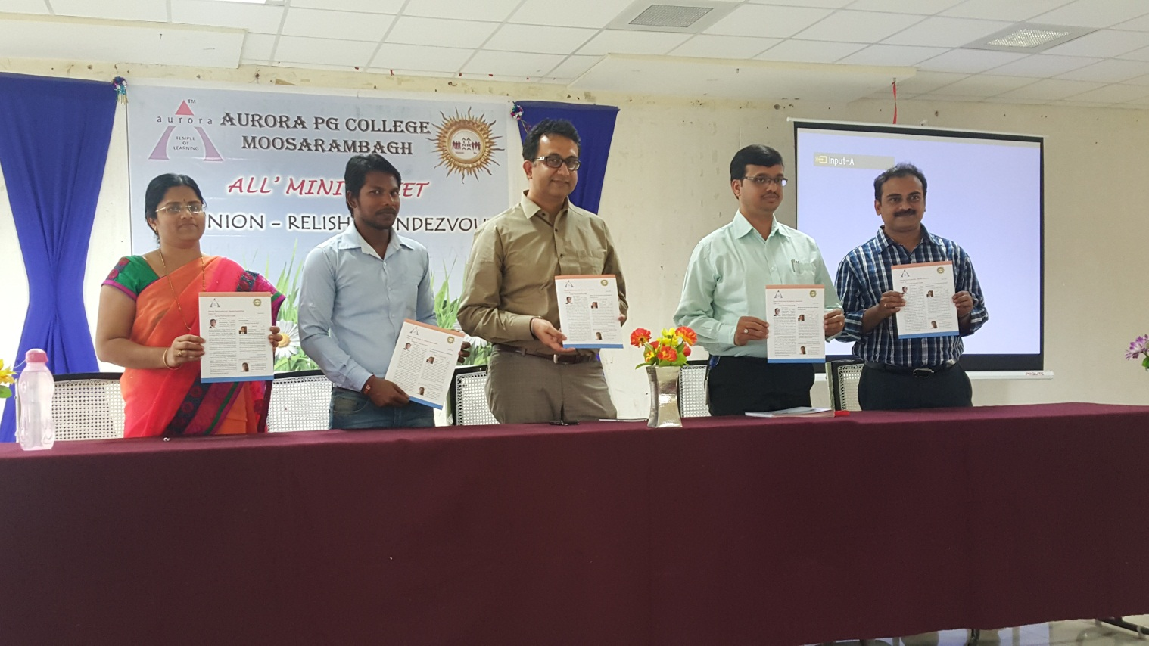

IT Quiz

On 28, IT Quiz was conducted for the students of MBA and MCA. The preliminary round or elimination round was writtenin which questions were pose on the areas of IT and DSS. Out of the total teams, 7 teams have been picked up for the next series of rounds. Finals consisted of four oral rounds. The winners of the competition werestudents of MBA IV semester and the runners were students of MCA II semester.

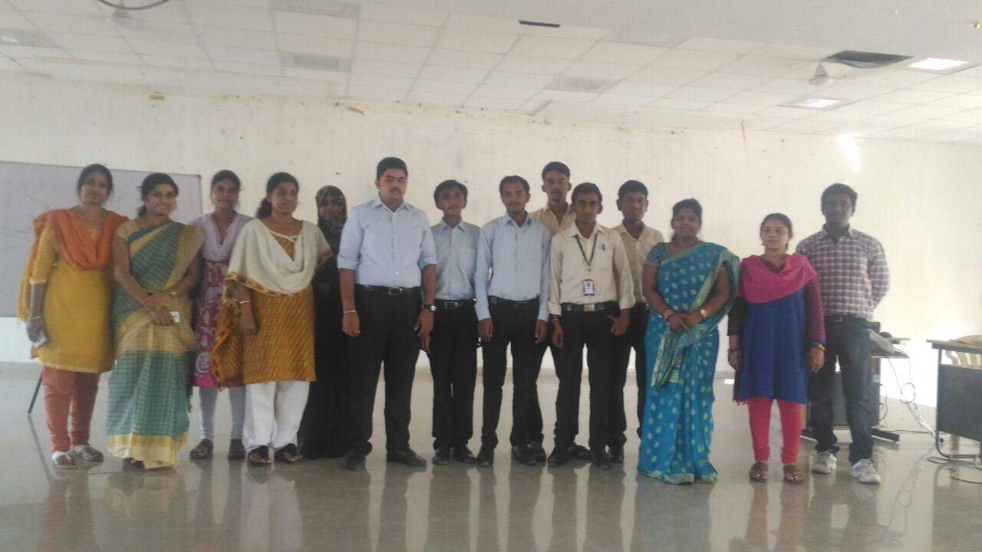

VikrayaVedika: Marketing and entrepreneurial activity

VikrayaVedika was organized by the II semester students of MBA in which used the event as a platform to exhibit their entrepreneurship, creativity and marketing skills. Stalls displaying cosmetics, fashion accessories, readymade garments, hand made decoration pieces, games and chocolates were put up in the Seminar Hall of the college by the students. Faculty members and students of MBA IV semester purchased the products displayed in these stalls.

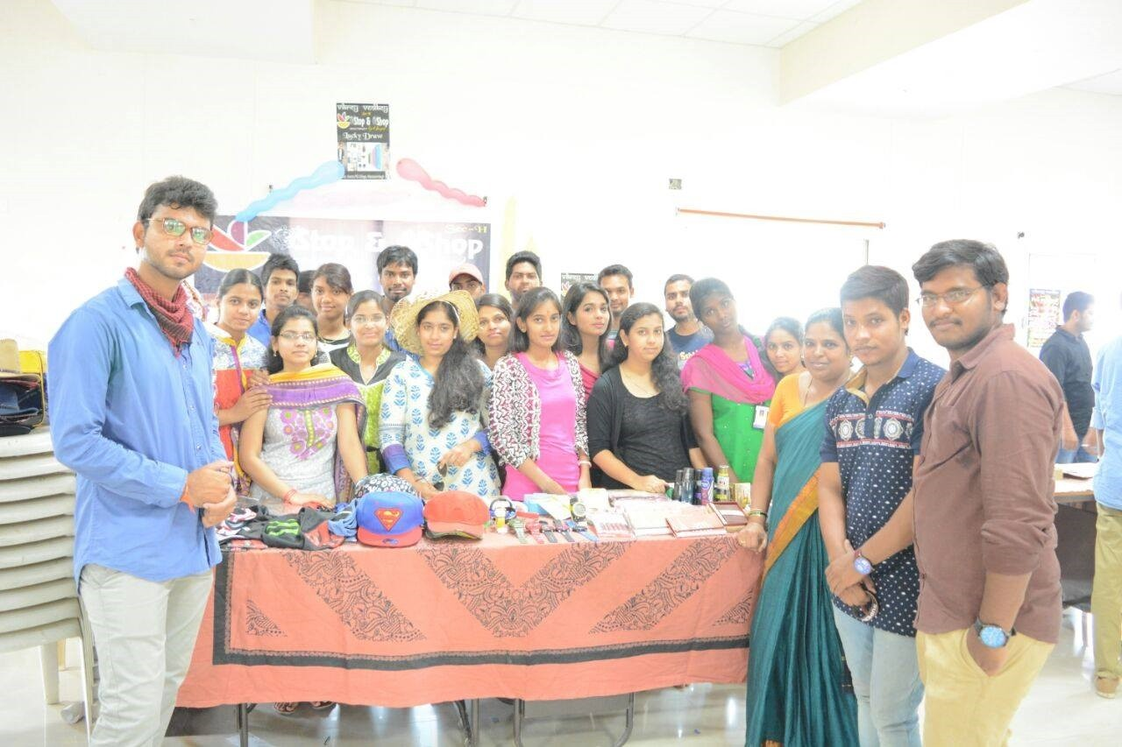
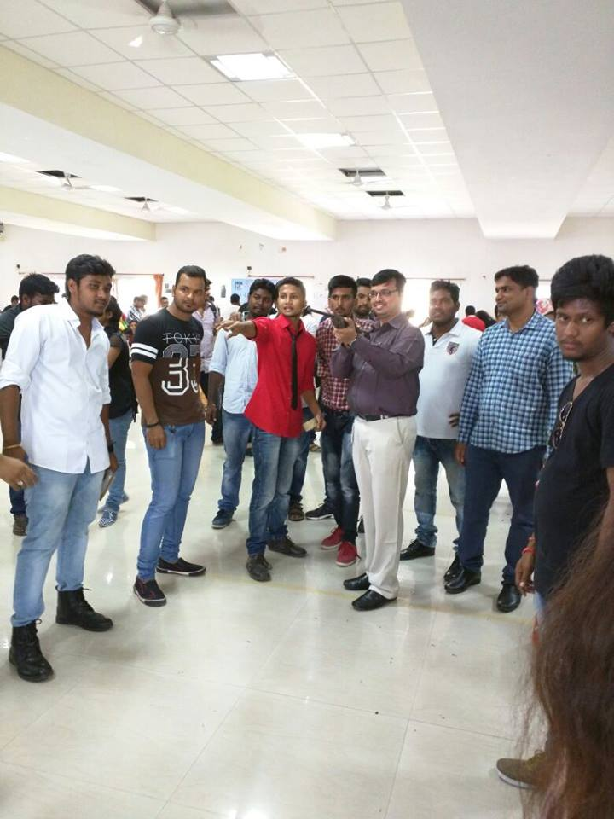

VikrayaVedika was organized by the II semester students of MBA in which used the event as a platform to exhibit their entrepreneurship, creativity and marketing skills. Stalls displaying cosmetics, fashion accessories, readymade garments, hand made decoration pieces, games and chocolates were put up in the Seminar Hall of the college by the students. Faculty members and students of MBA IV semester purchased the products displayed in these stalls.

Business Quiz
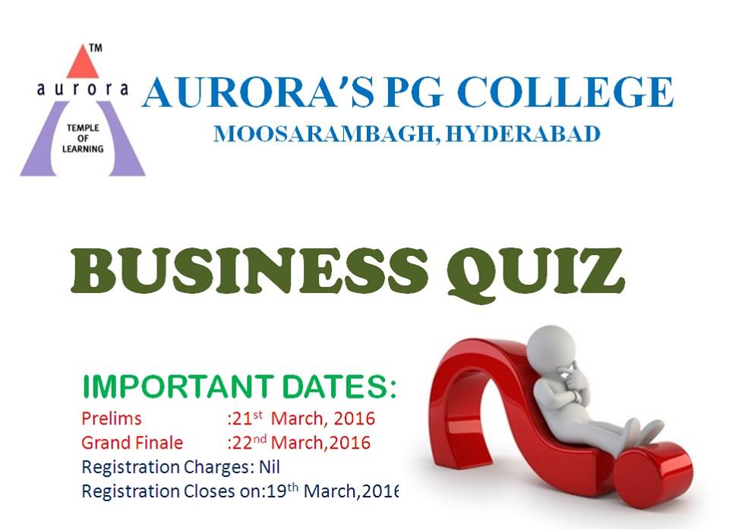

Business quiz was conducted on 21st and 22nd March 2016.. In the first round that consists of written test, 72 teams have participated enthusiastically. With three members in each team the total number of participants was 216 which was considered to be a whopping response. Twelve teams were short listed for the second round which is visual round. From the twelve teams, three teams were selected to be the winning team, runners and the team that secured the third place. The champions of business are:
TEAM | TEAM MEMBERS NAME | YEAR | SECTION
WINNERS | NAGARJUNA | IST YEAR | C SECTION
 | NANDISHWAR
 | SRINIVAS
RUNNERS | SAI KIRAN | II YEAR | A SECTION
 | VINAY KUMAR
 | PRADEEP KUMAR
THIRD PLACE | H RAVINDAR | II ND YEAR | F SECTION
 | B DEEPAK KUMAR
 | B ANURAG

Cricket Tournament-ACL (Aurora Cricket League)
Cricket tournament was organized by the college as a part of annual day competitions. The coordinators of the league are Mr. R. BhadraRao, Mr. SrinivasaRao and Mr. P. Ram Prasad. The teams that reached finals were students of Section G and Section F of MBA II semester Section C secured the III place.

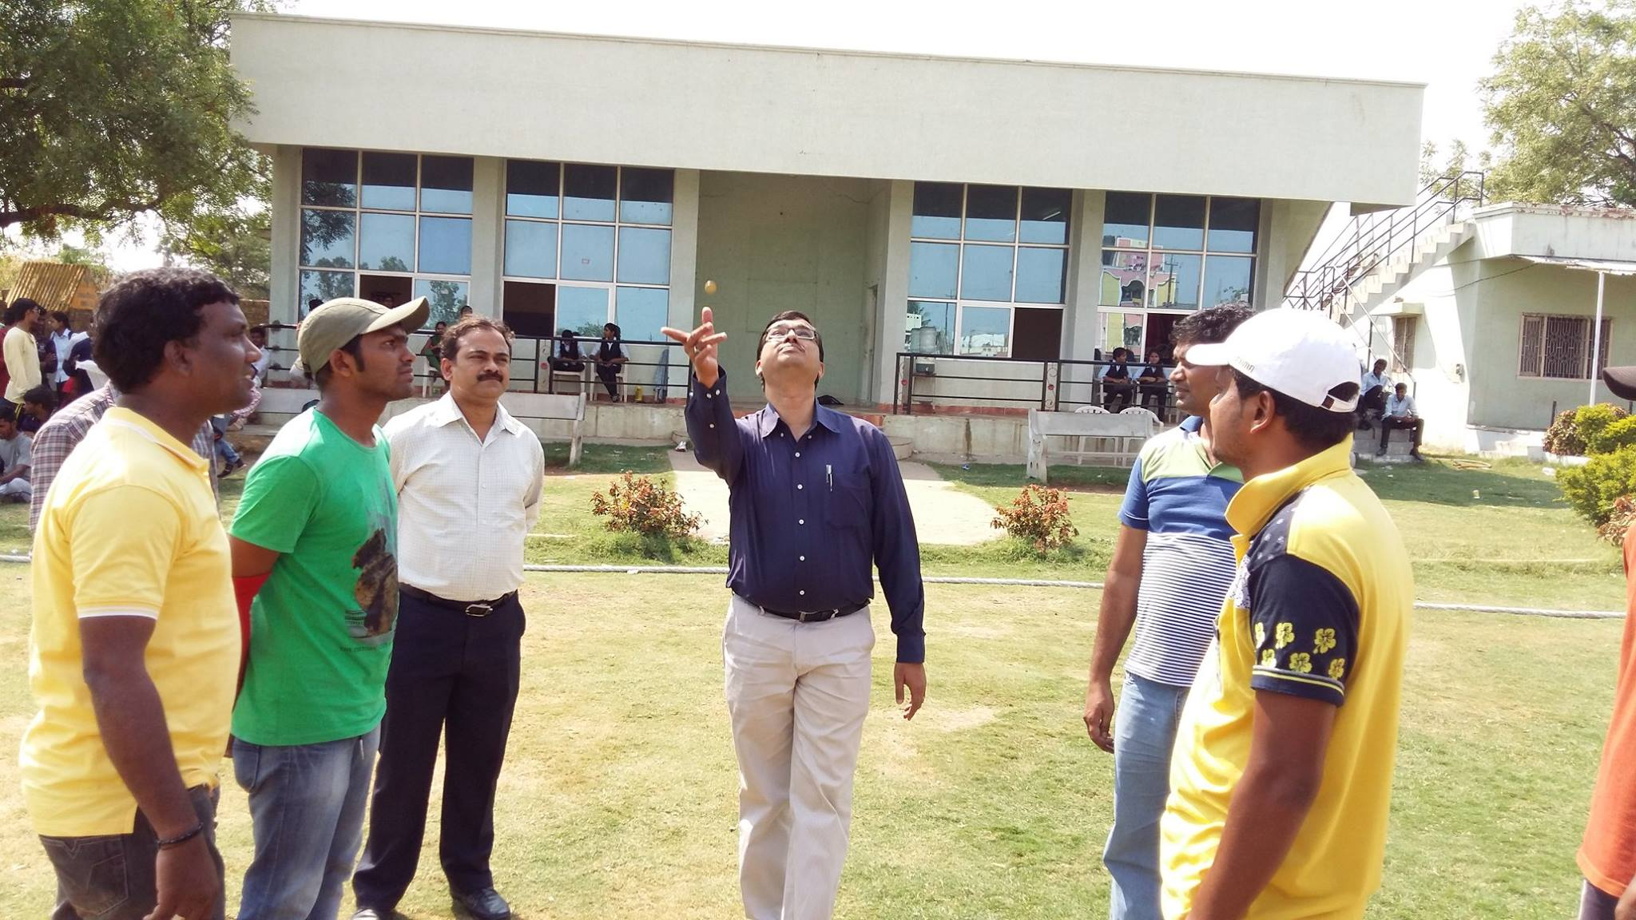

Important Dates in March
1st& 2nd March 2016 : External Lab Exam for I semester students of MBA
10th March 2016 : Offer of Internship for MBA II semester students by Birla Sun Life
10th& 11th March 2016 : I Internal exam for the students of MBA IV semester
15th March 2016 : Internship interviews by Bajaj Finance for students of MBA II semester

REALITY BYTES
Seminar organized by Youth Against Corruption (YAC)
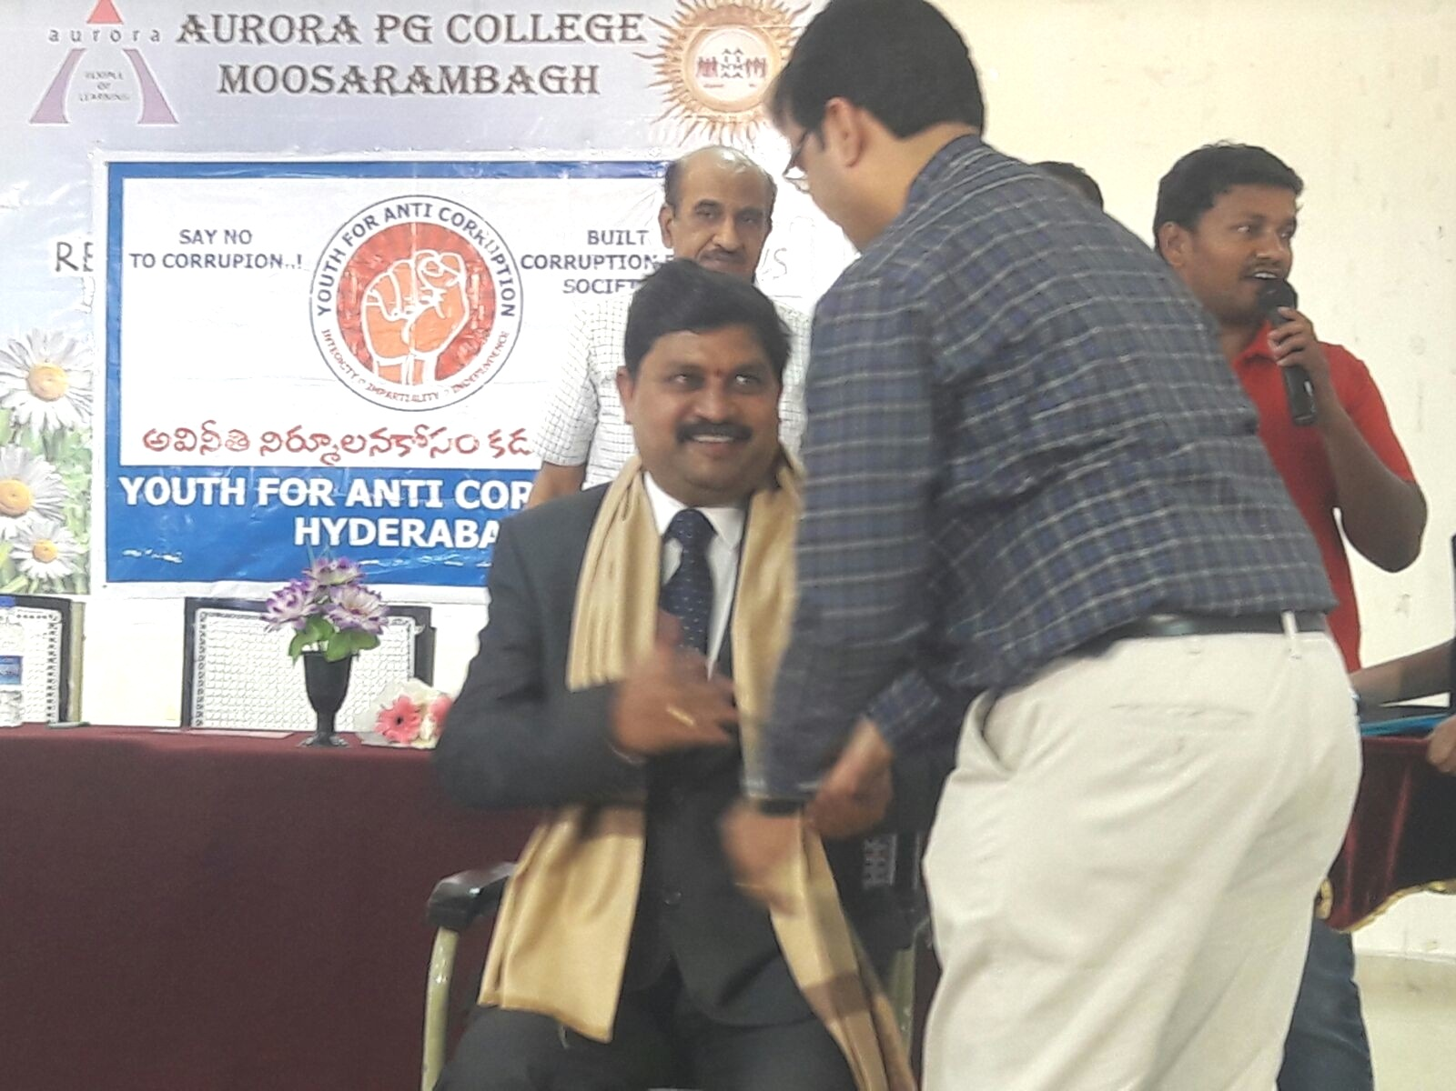
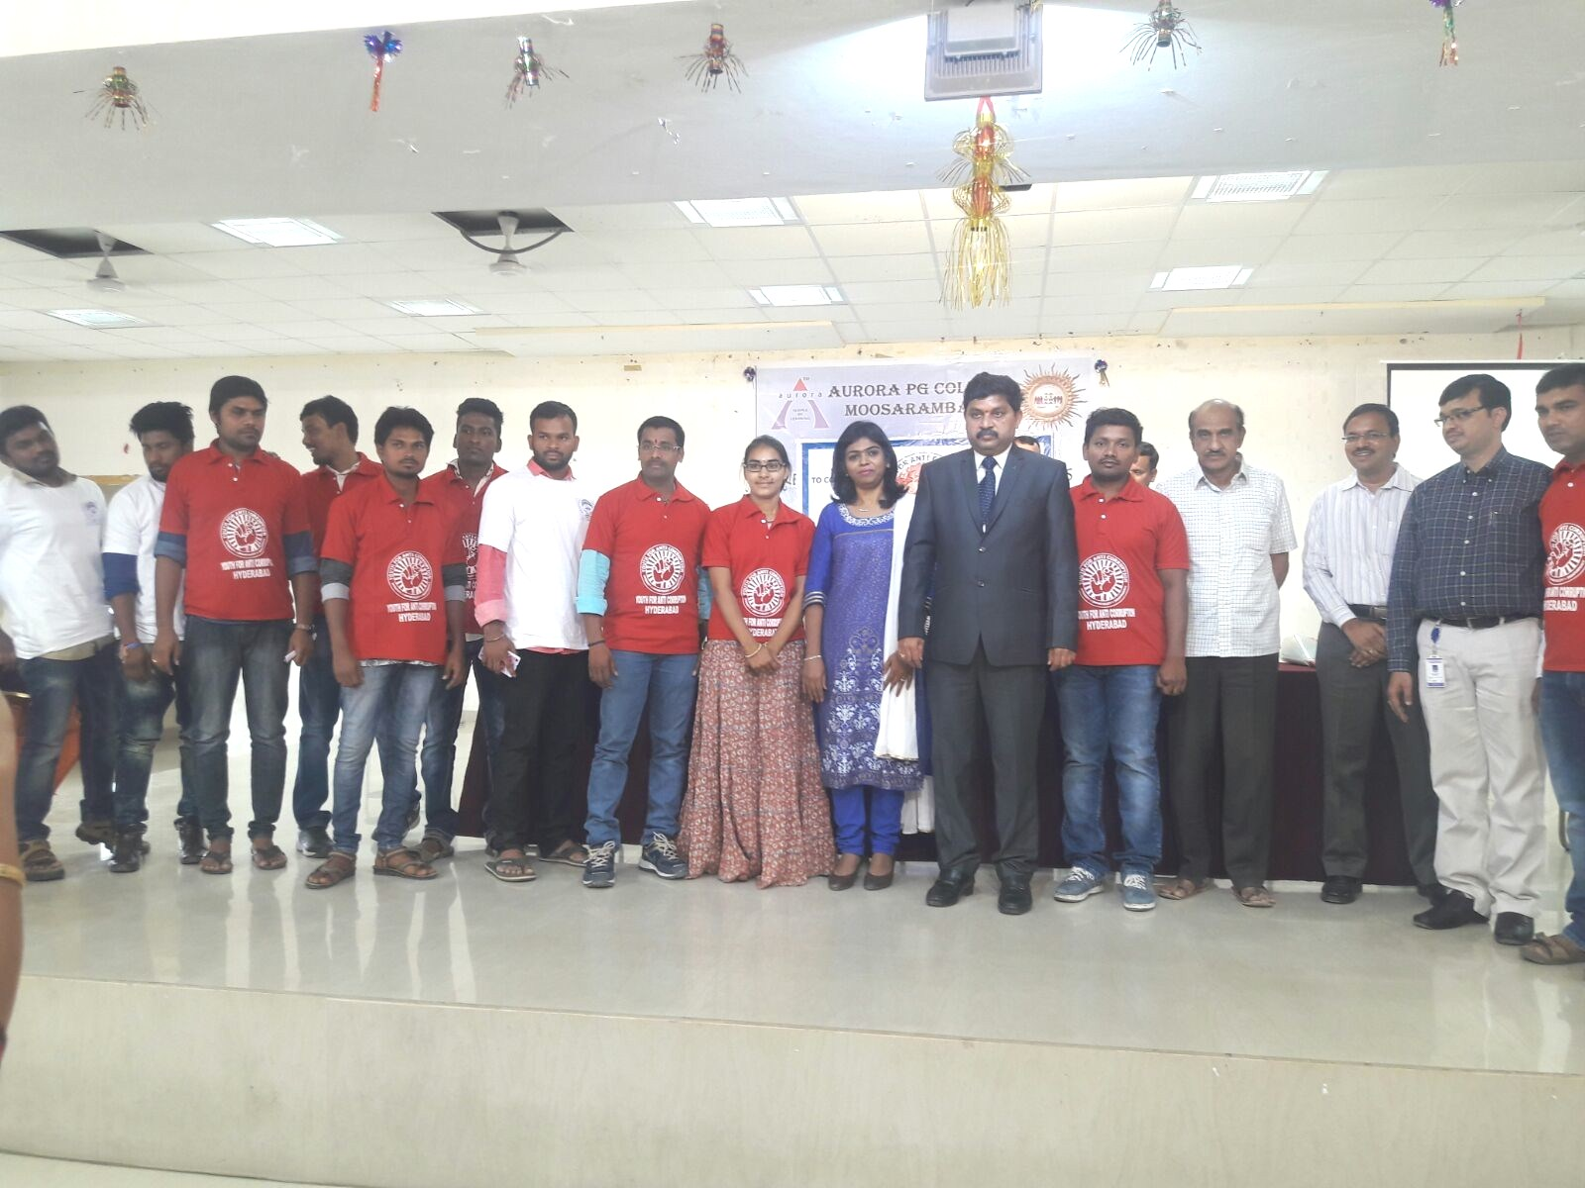
Students at Sankalp 2k16
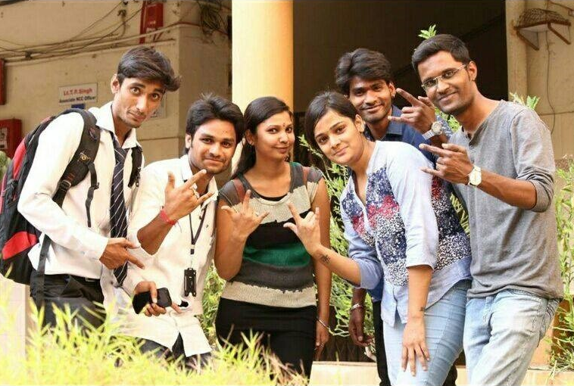
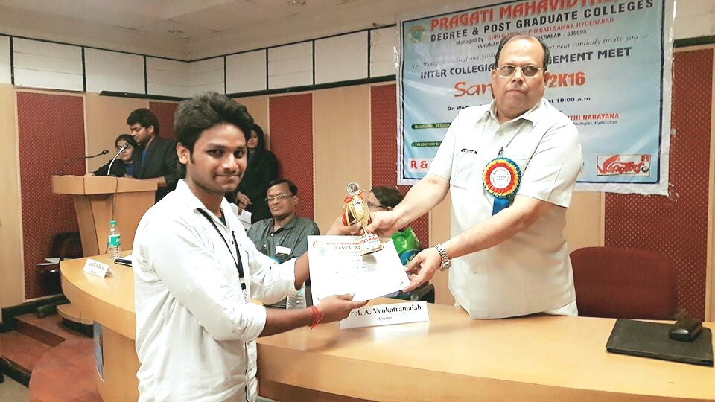

AURORA CRICKET LEAGUE
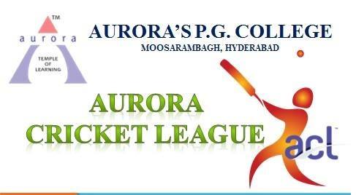

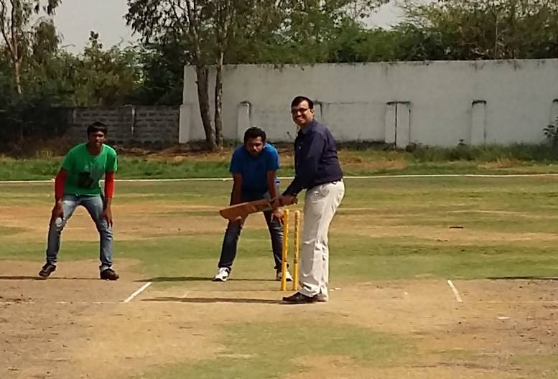

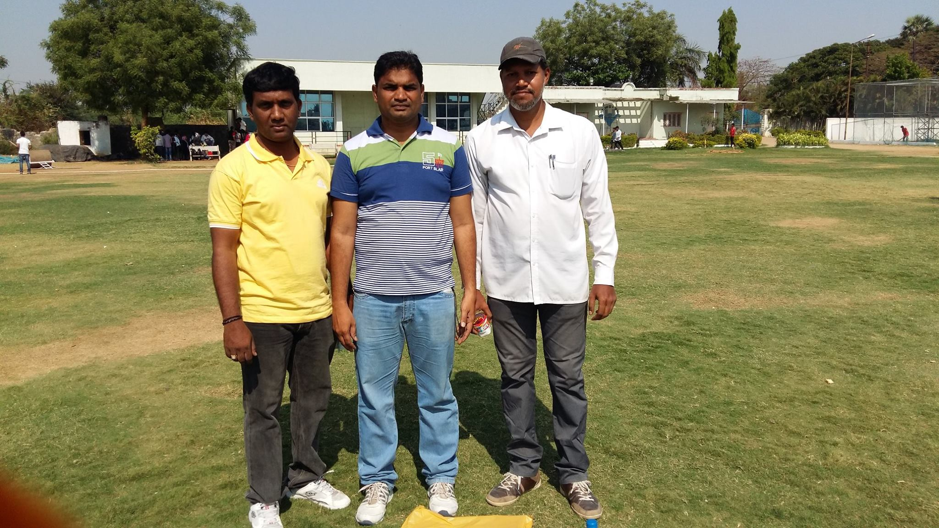

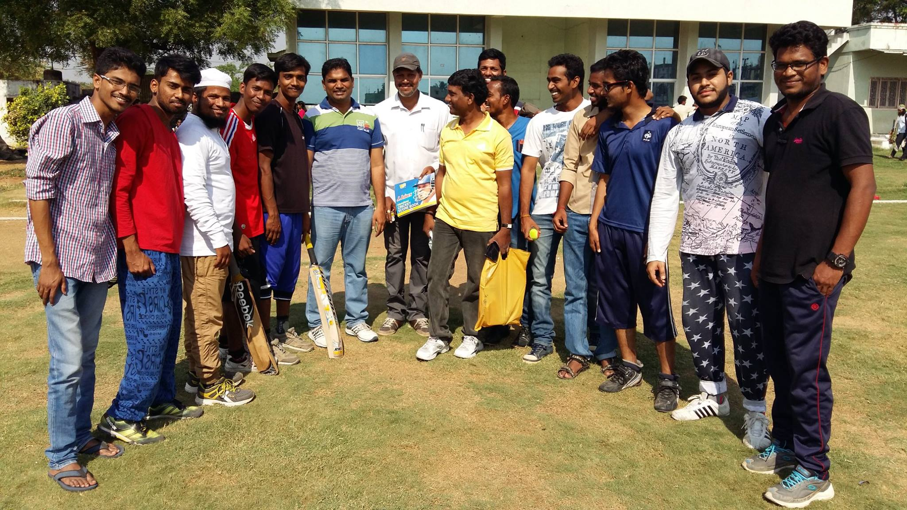
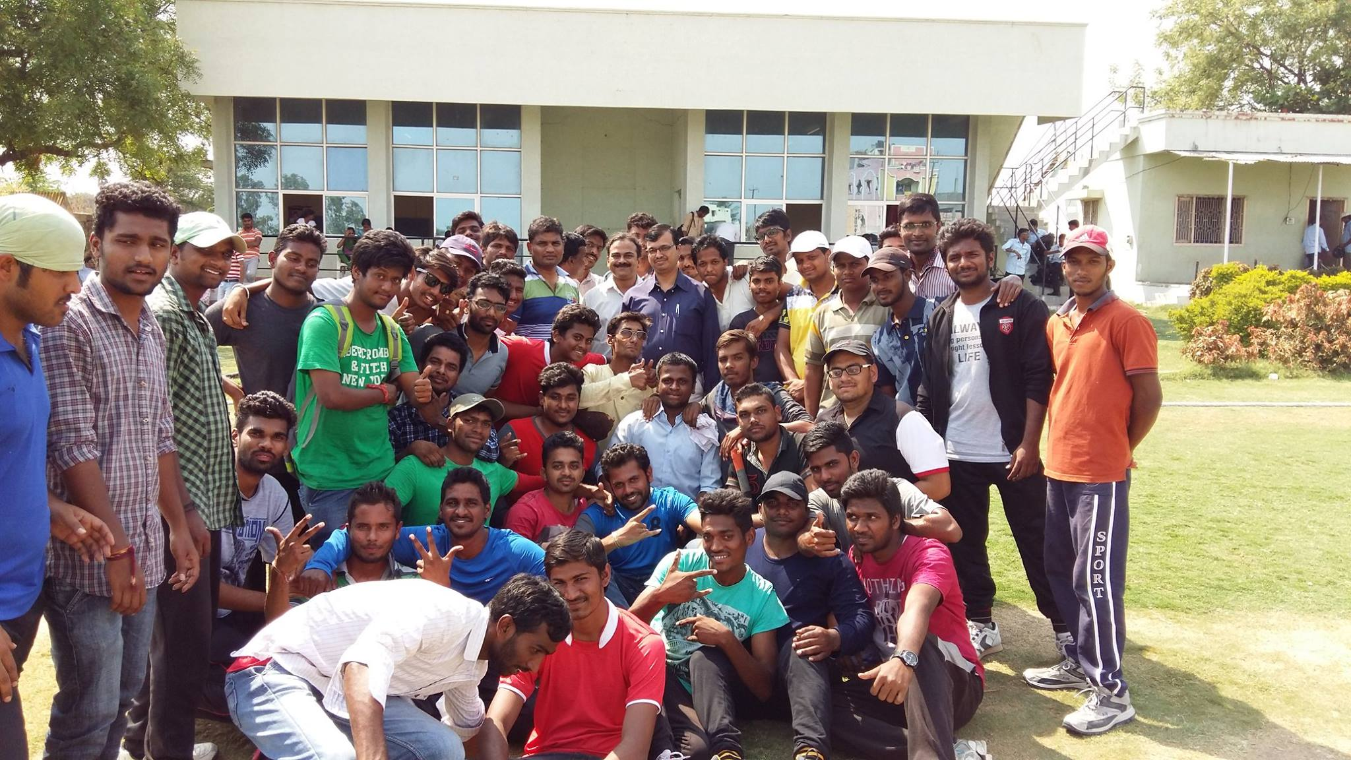
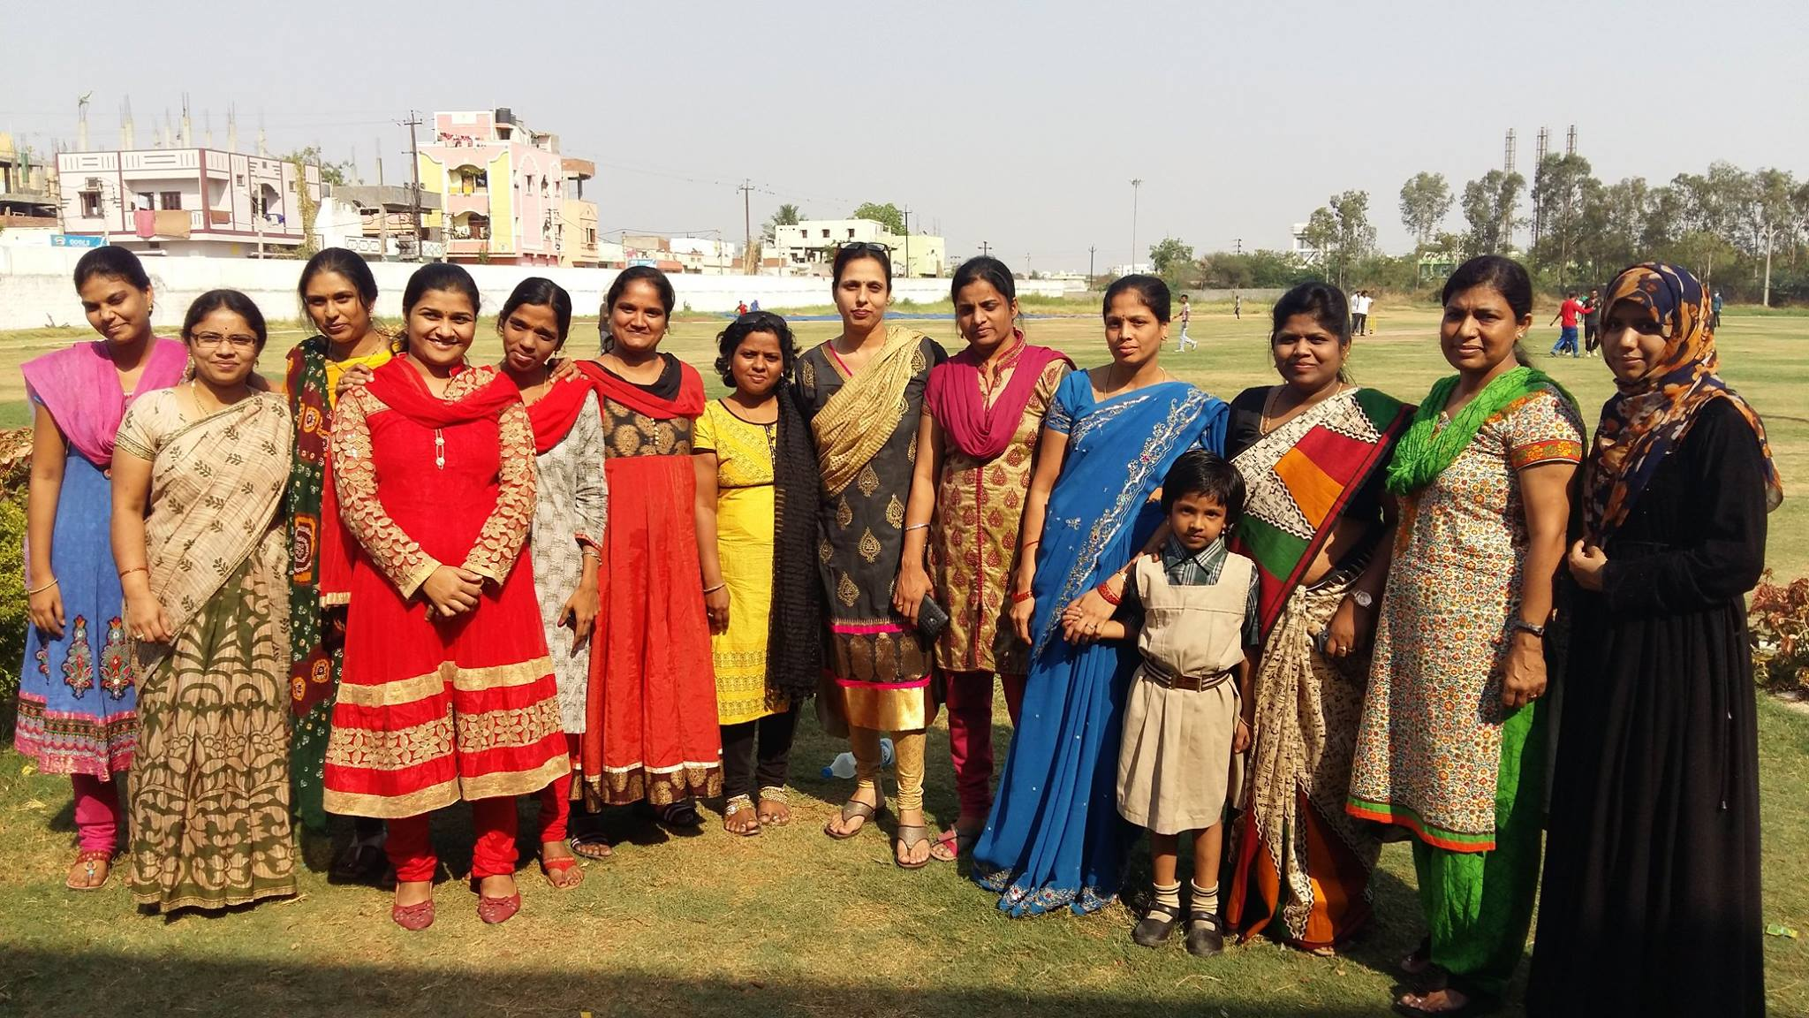

Alumni Meet
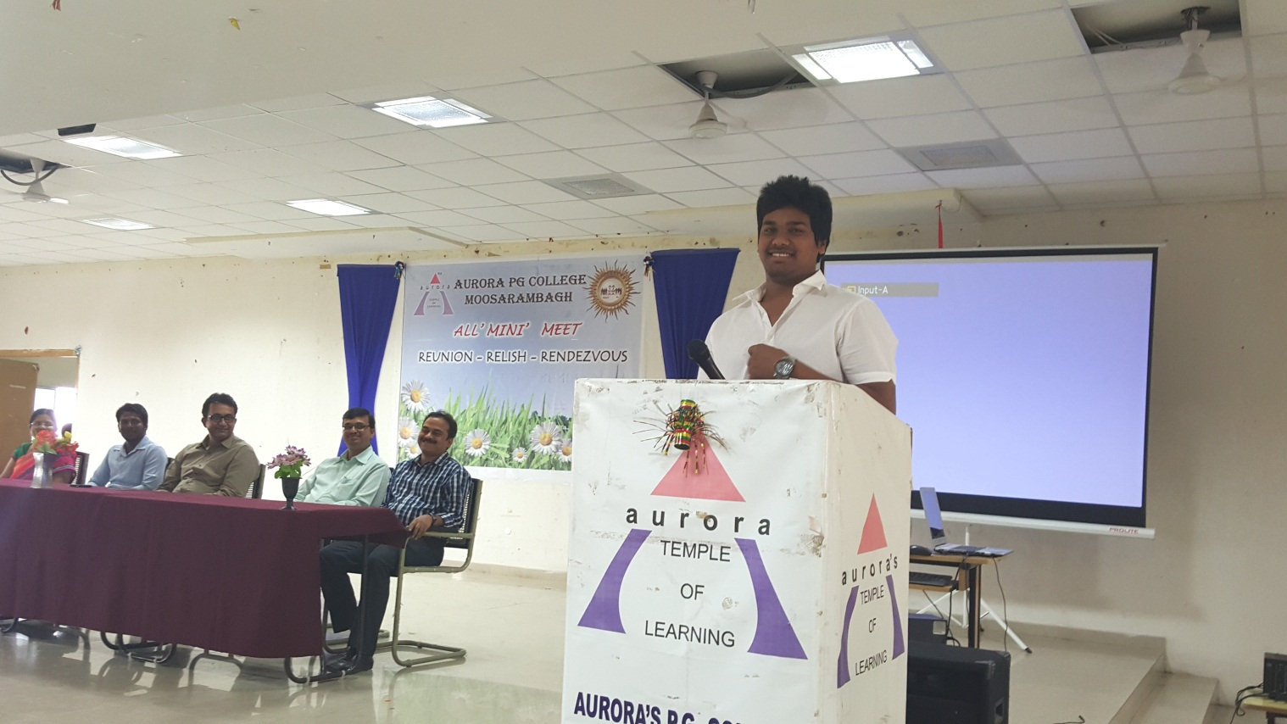
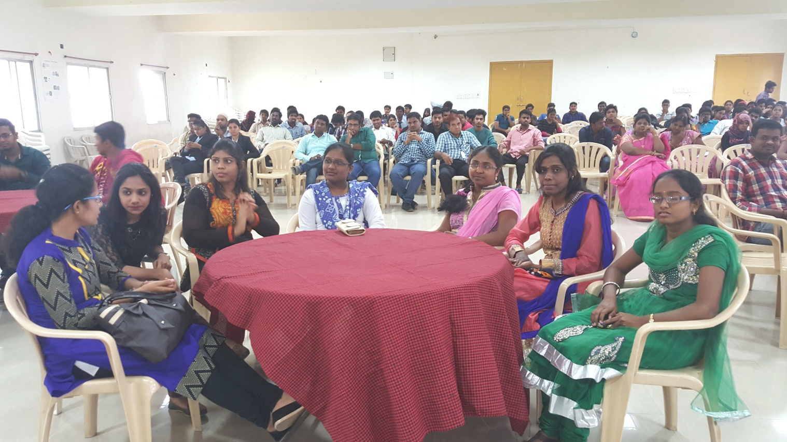
VikrayaVedika
